Sync User Roles from SAAS to Secondary Domain

Table of Contents
Audience: 1
Overview 1
Pre-Requisite: 1
OCI Confidential Application 1
Set the Oracle Identity Cloud Service Endpoint 1
Modify Profile Options 1
Setting up Role and Role Assignment synchronization 1
Set up Oracle Enterprise Scheduler (ESS) Job for repetitive or ad-hoc synchronization. 1
Review and monitor synchronization data. 1

Audience:

- ERP / HCM System Administrator
- IAM Admins
- Infrastructure Admin

Overview

The below diagram shows the federation between various ejep-* domains and Azure. There are users/roles that will be synced from SAAS (PATH) environment into ejep-* domains and so users needing to access a VBCS application (runtime) are authenticated using the principal shared between SAAS and the OCI domains with Azure AD

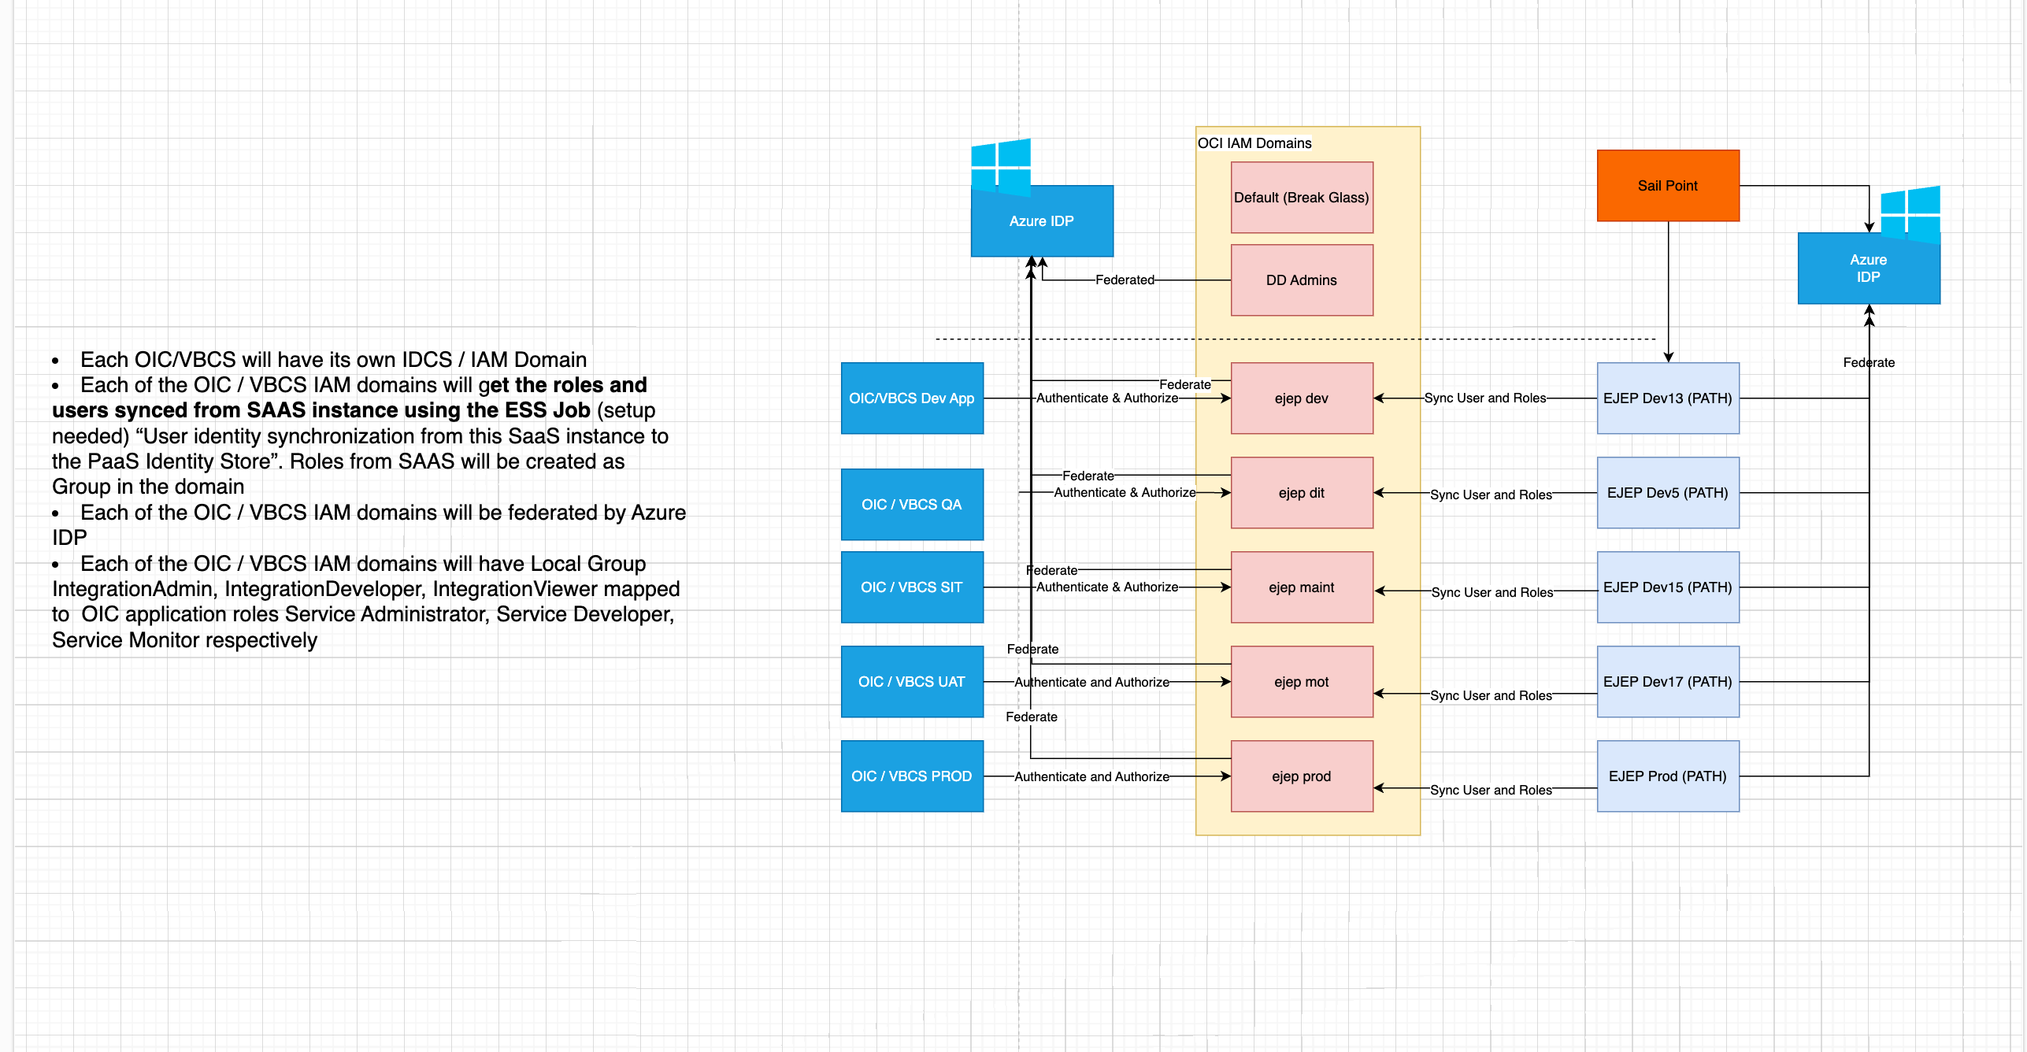

- Each OIC/VBCS will have its own IDCS / IAM Domain
- Each of the OIC / VBCS IAM domains will get the roles and users synced from SAAS instance using the ESS Job (setup needed). User Identity synchronization from this SaaS instance to the PaaS Identity Store. Roles from SAAS will be created as Group in the domain.
- Each of the OIC / VBCS IAM domains will be federated by Azure IdP
- Each of the OIC / VBCS IAM domains will have Local Group IntegrationAdmin, IntegrationDeveloper, IntegrationViewer mapped to OIC application roles Service Administrator, Service Developer, Service Monitor respectively.

Pre-Requisite:

These steps must be performed on each ejep-* domains defined.

- Confidential Application within each domain with Identity domain administrator privilege. This confidential application will be used by Fusion environment (aka SAAS or PATH within Customer CA) to synchronize the fusion users into EJEP-* domain. Each domain is seeded with a Confidential domain already and please obtain the Client Id and Client Secret

- Access to Oracle Fusion Environment as IT Security Manager.

OCI Confidential Application

These are the corresponding confidential applications for each domain.

Domain | Confidential App  (us-sanjose-1 Region: Navigate -> Identity and Security -> Domains) | IDCS Host | Client ID/Client Secret
ejep-dev | OIC-App |  | <Infra team can provide this>
ejep-dit | OIC-DIT |  | <Infra team can provide this>

Set the Oracle Identity Cloud Service Endpoint
Now you configure Fusion Service to enable back-end communication with domains (OCI IAM Domains).
- Sign into Fusion Service as administrator or setup user.
- In the Setup and Maintenance work area.

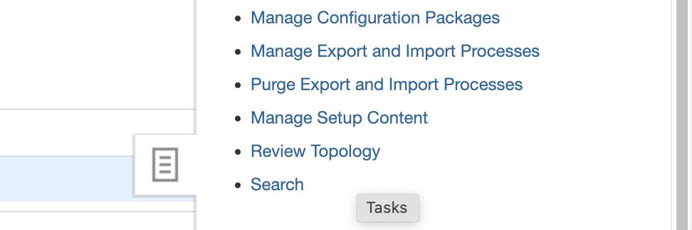
- Click the Tasks icon, then click Manage Setup Content.
- Click Manage Integration of Additional Applications.

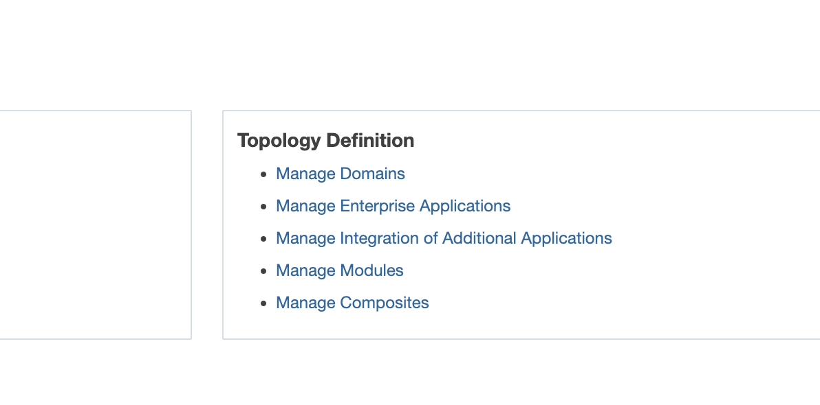

- In the Search Results area, click the Actions menu, and select Create.
- In the Create Application Integration form, enter the following:

Application Name | IDCS_REST_ENDPOINTAPP
Full URL | https://<IDCS HOST>/admin/v1  Note: This is the IDCS host that authenticates the Visual Builder instance. IDCS Host alone is listed above table. Please don’t forget to append /admin/v1
Partner Name | IDCS

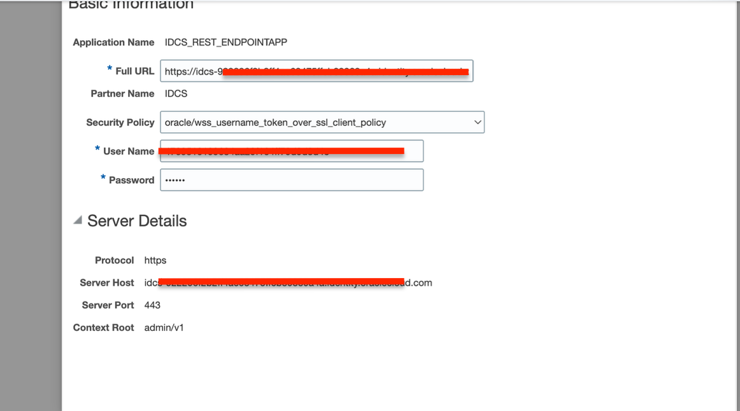

- Click the Apply button and then verify the Protocol, Server Host and Context Root details are populated in the Server Details area.
- Click Save and Close.

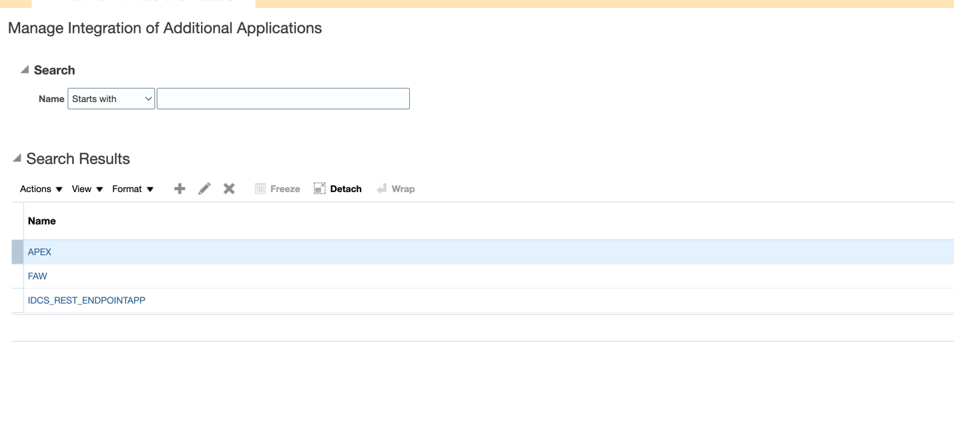

Modify Profile Options

FND_USER_MIGRATION_FETCH_BATCH_SIZE: 10000
FND_ROLE_SYNC_MAX_SELECTED_ROLES_SIZE: 20
FND_SYNC_JOB_TYPE: ALL
FND_USER_IDENTITY_SYNC_TARGET: IDCS
FND_USER_MIGRATION_MAX_RETRY_ATTEMPTS: 20
FND_USER_MIGRATION_FA_ENV_NAME: dev13 <prefixing if you want to the roles>
FND_USER_MIGRATION_FA_FEDERATION: true <This SaaS PaaS sync job profile is for enabling the federation of synchronized users>

To set up the above profile options, follow the below instructions
- Navigate to Setup and Maintenance, and search for “Manage Administrator Profile Values.”
- Click on the task to manage profile options.
- Search for specific profile options and update the value as required, Click “Save”
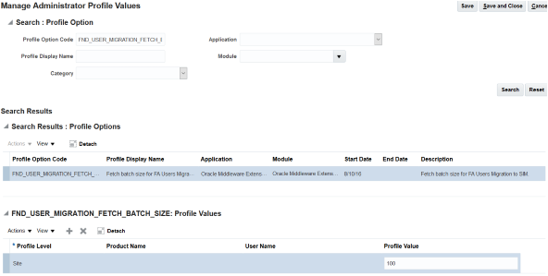

- When done for all profile options, click “Save and Close” > “Done”

Setting up Role and Role Assignment synchronization

- Login to Fusion Application with administrator access

- From the “Navigator” go to “Setup and Maintenance” , Task Icon and click on Search.

- In the search , enter “Migrate Enterprise Roles and Assignments to PaaS Identity”

- Click on the searched task, click “+” icon to add roles that you want to migrate to Domain.

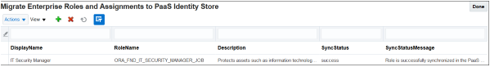
- Role assignments of only those selected role will be synced to IAM Domain

- The maximum number of roles you can select here is as per the “FND_ROLE_SYNC_MAX_SELECTED_ROLES_SIZE” profile value.

- Remove the role if you want to delete already synced role in IAM Domain

Set up Oracle Enterprise Scheduler (ESS) Job for repetitive or ad-hoc synchronization.

- Login to Fusion Application with administrator access

- From the “Navigator” > “Tools” > “Scheduled Processes”

- Click “Schedule New Process”

- Click the down arrow icon at the end of the Name field to open the process name list and find “User identity synchronization from this SaaS instance to the PaaS Identity Store.”

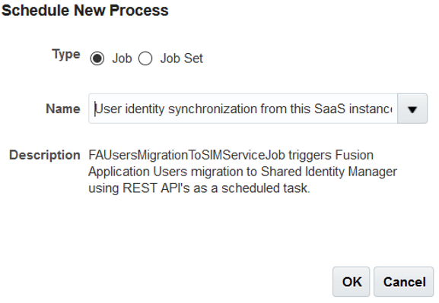

- Click “Ok” to open the “Process Details” page.

- Click “Advance” to configure the schedule frequency.
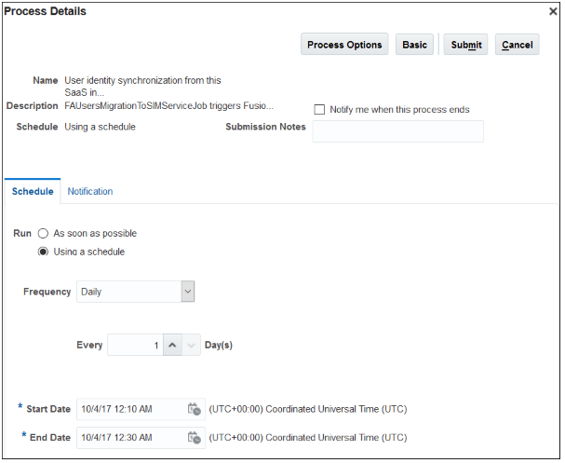

- Click “Notification” tab to configure notification.

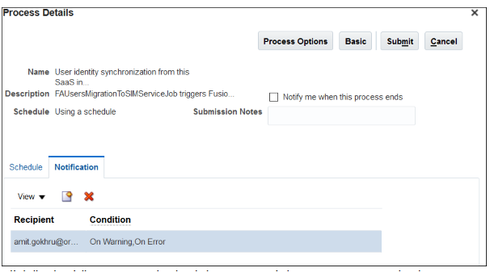

- Click “Submit” to save and schedule your ESS job to sync users and roles to Domain.

Review and monitor synchronization data.

- Login to Fusion Application with administrator access

- From the “Navigator” go to “Setup and Maintenance” and search for task “Manage User Identity Synchronization to PaaS Identity Store”, click on the task to see the detailed report for sync status.

This completes the user, role and role assignment synchronization from Fusion Application to IAM Domain

